
Block chain and crypto currency technology


Block Chain Technology

Name: Daniel Kabala
Instructor: Mrs Boan
Date: 11/12/19
Trading through Cryptocurrency has been difficult due to issues of regulating the currency. However, the bitcoin currency prospers due to the blockchain platform which hosts the transactions. The blockchain mechanism allows the movement of transactions in the form of blocks which are present on a public ledger that do not require accountants for auditing (Crosby 9). Although the initial concept of Cryptocurrency did not materialize, arguably the blockchain technology is one of the positives from the Cryptocurrency tide.
The blockchain technology allows for copyright and patenting of academicians work (Mazor). As technology has grown, the means of protecting the work of various authors have been met with multiple stumbling blocks. For instance, with the evolving online trends it becomes difficult to monitor the work of an author’s due to the presence of intermediate sites that provide cheaper alternatives. As a result, most of the authors end up not benefiting from their hard work.
Arguably, the infrastructures that have been set up in the current society are insufficiently protecting an author work (Mazor). Nonetheless, the blockchain technology offers a better solution towards making sure that the work published by an author is adequately protected. Once an author’s work is submitted it functions as a block, on a public ledger which makes it simple to monitor the movement of the blocks (Mazor).


To conclude this discussion, the blockchain technology is one of the positives that have graced the current technology.

Additionally, blockchain can be used in improving the transparency in an electoral process (Noizat 453). Traditional means of elections have already proven to be unreliable in conducting a free and fair election. Massive election rigging has become the norm in the electoral process with case studies in Kenya and the concluded 2016 presidential elections. From the results of the rigged elections, it has become clear that technology can become double-edged blade as it was the main ingredient in rigging the elections. Technology has made it simple to rig elections without physical presence but conduct it remotely from a distance.
However, it is possible to counter the problem by using more advanced technology in monitoring elections (Noizat 459). The blockchain technology offers an appropriate solution towards reducing the probability of rigged polls and creating transparency in the process. The blockchain technology provides an alternative where the voters can vote remotely using their mobile phones.
To conclude this discussion, the blockchain technology is one of the positives that have graced the current technology. The traditional means of conducting business have proved to be obsolete owing to their unreliability in the most crucial moments. The conventional methods have had their vulnerability due to the presence of a third party or intermediate in executing specific functions. However, the blockchain network provides a smart contract where the services of the third person are not needed, thus decentralizing various processes. In essence, the time has dawned when humanity puts aside the Neanderthal structures of oppression and embraces the blockchain technology that offers a fresh air into civility.

Work cited
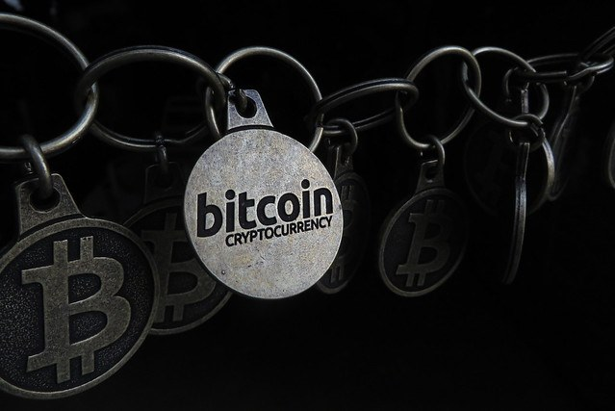


Crosby, Michael, et al. "Blockchain technology: Beyond bitcoin." Applied Innovation 2 ,2016.pp. 6-10.
Mazor, Hadar. Can Blockchain Technology Solve Copyright Attribution Challenges of Digital Work? 2018. Accessed on 20th June 2018 from, http://www.ipwatchdog.com/2018/02/02/blockchain-technology-solve-copyright-attribution-digital-work/id=93161/
Noizat, Pierre. "Blockchain electronic vote." Handbook of digital currency. 2015. 453-461.
You Tube Links
https://www.youtube.com/watch?v=jKYhLpHJv8U
https://www.youtube.com/watch?v=qOVAbKKSH10
https://www.bloomberg.com/news/articles/2019-11-12/blockchain-is-dead-crypto-geeks-debate-merits-of-once-dear-tech

